ENM500 – Petroleum Geoscience Tutorial - 2

1. Use figure 1 below;

1. Delineate possible sand zones from the log.
2. Make a record of the gamma radiations for the sand zones at intervals of 10 ft
3. Would you say that the sand is clean or shaly, justify your answers

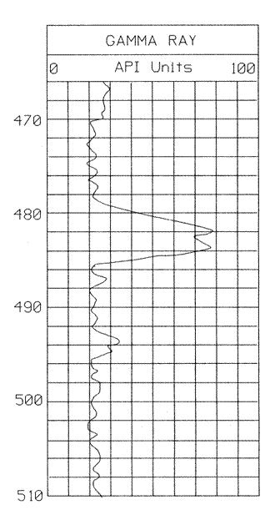

Figure 1

2. List the key properties of a formation that would lead you to conclude that the formation is a reservoir rock.

3. List the physical characteristics of formation that are usually exploited in log measurements and state the corresponding reservoir properties inferable from these measurements

4. Use figure 2 below to answer this question;

1. Construct a lithologic column for the formation using the gamma ray log
2. Assume that the formation is of tertiary age, estimate the volume of shale between 1200 ft and 1400 ft
3. On the basis of the results obtained above, describe the formation at this depth interval in terms of its reservoir quality

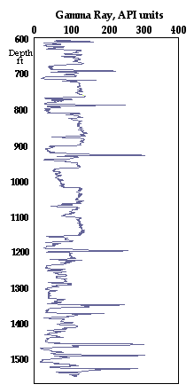

Figure 2

5. What are the possible sources of error in the density porosity estimation?

6. Use figure 3 below;

1. Delineate the possible reservoir zones on the log and estimate the density porosity for each zone (assume the reservoir zones contain water)
2. Delineate the possible reservoir zones on the log and estimate the neutron density porosities for each zone (assume the reservoir zones contain water
3. Compare the estimated density and neutron porosities; account for any disparity or uniformity in their values.



Figure 3

7. Explain in details the effects of presence of shale and gas in a formation on its neutron porosity.

8. Given the original Wyllie Time-Average equation (see below), derive the porosity equation



9. Use figure 4 below; determine the water saturation at depths 10000 ft, 10050 ft to 10100 ft

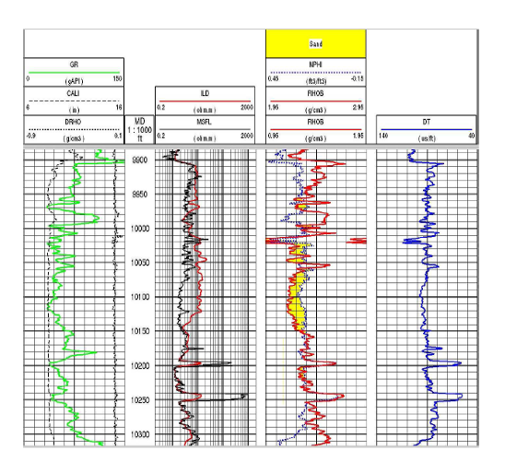

Figure 4

10. Describe the physico-chemical properties of shale that may affect the estimation of porosity of a shaly sand formation using the porosity logs

11. Given

Rw = 0.04 ohm-m at FT

Rt = 27 ohm-m at FT in the zone of interest

Δt = 84 µsec/ft in the zone of interest

 = 2.31 g/cm^3

 = 2.67 g/cm^3

 = 1.02 g/cm^3

1. In a sandstone matrix, with an acoustic velocity of 200 µsec/ft in the fluid and 80 µsec/ft in the matrix, calculate porosity using the two weighted average equations, one for density and one for acoustics
2. Is the value of porosity the same or about the same for both the density and acoustic models? If there is any significant difference in their values, explain the factor(s) that might be responsible for this difference
3. Using the calculated density porosity in (a), calculate fluid saturation from the Archie’s relationship where “a” = 1.37, “m” = 1.80 and “n” = 1.65. If the critical Sw is 45%, describe the hydrocarbon productiveness of the formation

12. The minerals that make up reservoir rocks give off Natural Gamma Radiation. What are the three radioisotopes that are commonly detected using the Spectral gamma method

13. The porosity measured in a formation is dependent upon the physical properties of the fabric making up the formation. Detail the principal controls on porosity

14. In a wellbore, logging strings consisting of resistivity logs and both neutron and density porosity devices were run. What physico-chemical properties of the clay minerals present in the sandstone formation of interest may influence the formation evaluation and why? Give an example in each case.

15. The invasion of the drilling fluid into the formation results in a fluid distribution profile when a well is logged. Sketch the resultant resistivity profile in terms of its distance away from the well bore, and show the relative resistivity of deep, medium and shallow investigation logs when run in (a) water zone and (b) oil zone

16. Describe the following terms using sketches where necessary. Underline their importance and usefulness in the estimation of hydrocarbon initially in place (HIIP)

* + 1. Net sand
    2. Net reservoir
    3. Net pay

17. The gamma ray log shapes shown in figure 5 were obtained from different formations (at different depths) in the same well; based on these shapes describe the depositional history and environments of deposition of the formations encountered in the well.

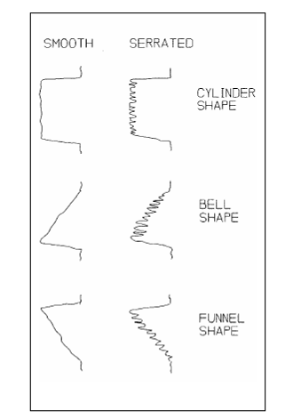

Figure 5